Alexamara Marina Group Database User Manuel

**Intro**

This is the user manual for the database designed by Michael Martin for the use of Alexamara Marina Group. The purpose of this manual is to provide support for using and navigating your way around the Alexamara Marina Group database.

There are two general sides of this database, reporting and maintenance. The reporting side is used for generating reports about various information. The maintenance is used for adding data, deleting data, and updating data to the database.

**Software/Hardware**

There are a number of hardware pieces needed for this database the first is a server in which to host the database and give it a place to store information. Software you will also need phpmyadmin which is used to create the database.

**Apendix**

Open up to the Homepage

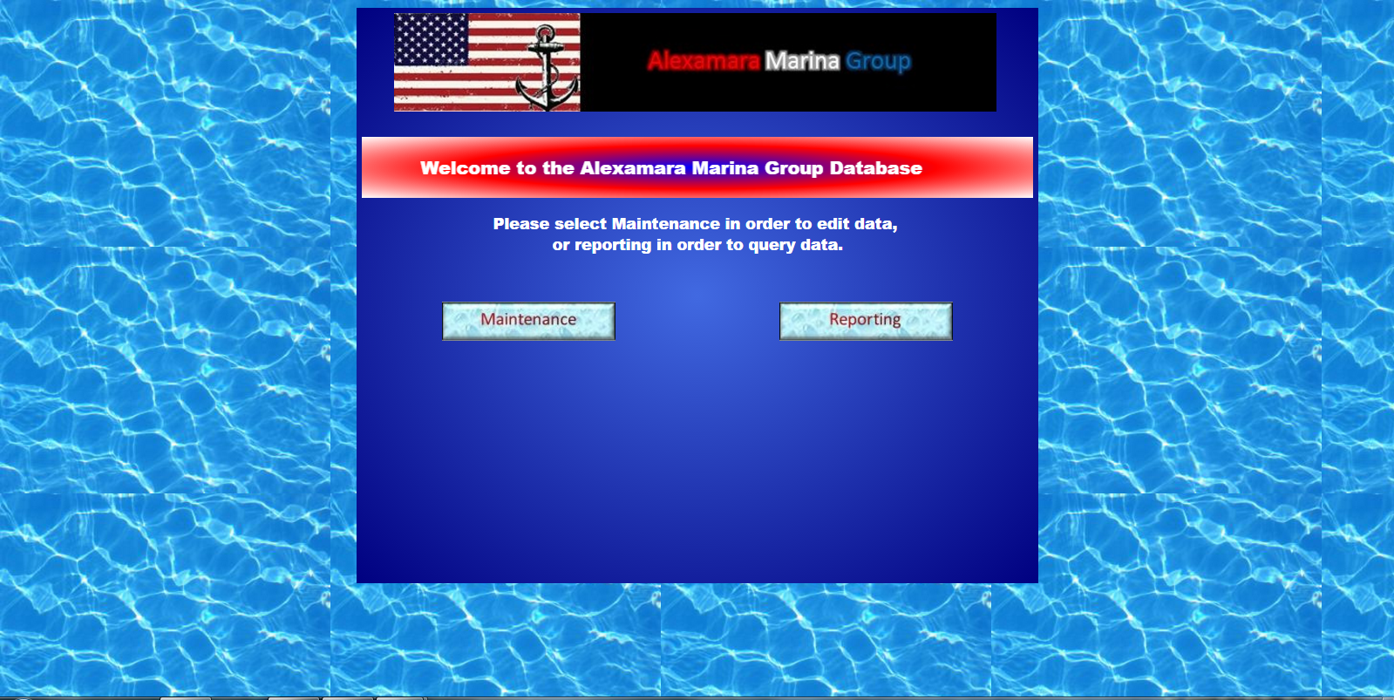

From the home page, clicking maintenance will bring up the following page:

The user can navigate back to the homepage by clicking the back to homepage button.

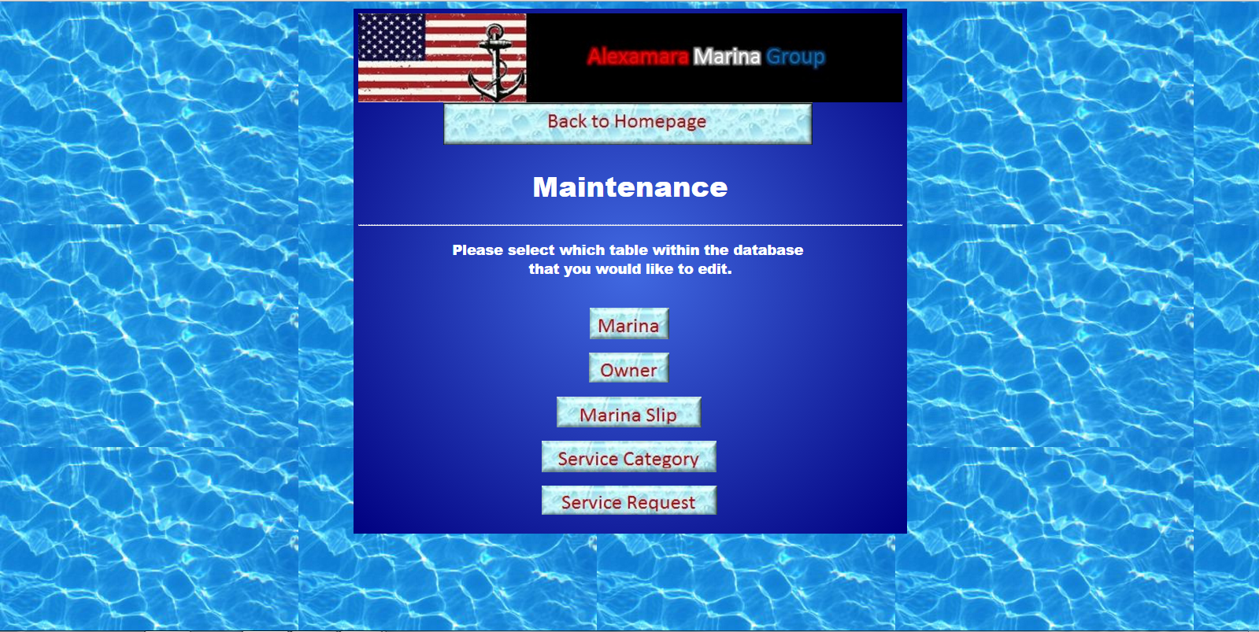

The maintenance process is about the same for every table, so I will go over how to perform maintenance on the MARINA table.

To change/add/delete records in the MARINA table of the database, click on the marina button.

From here you can modify, add, and delete information from the marina table. To first bring up a marina’s information, type a valid marina number into the top textbox and hit retrieve data.

Also, from any page within the maintenance portion of the site, there will be a button towards the top of the page that will direct you back to the main maintenance page.

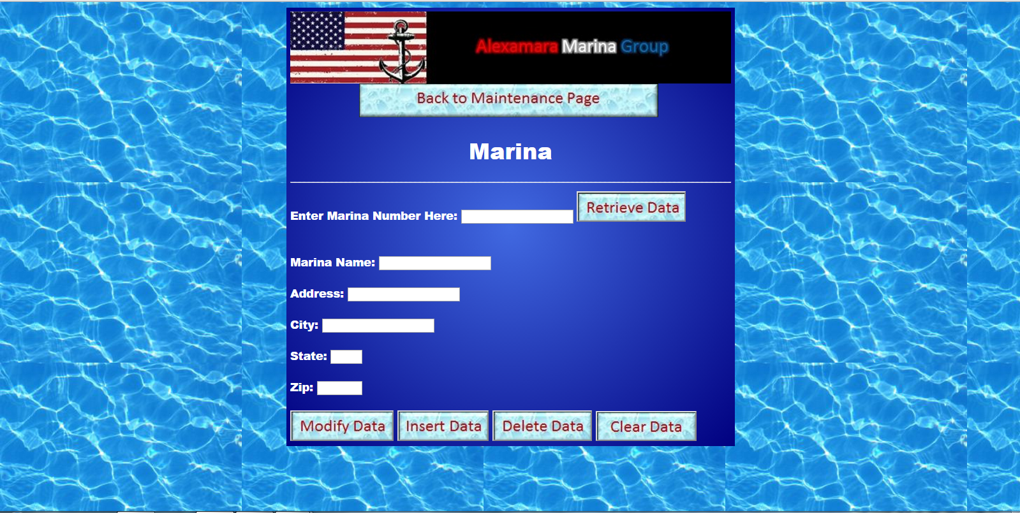

If you do not enter a marina number in the top textbox or enter a marina number that doesn’t exist, then attempt to retrieve the data, an error message will be displayed on the page

Once a valid marina number has been entered and retrieved, the values pertaining to that marina will be filled into the corresponding textboxes.

From here you have all information pertaining to that marina.

When modifying, deleting, and inserting a marina; if any textbox is left empty you will be prompted to enter all the required missing data.

You can modify a current marina by retrieving the data for the marina and changing the data that needs to be changed then clicking modify data.

To insert data, enter the data for the new entry you wish to make in the fields provided, leave the top marina number field blank. Once you click insert data, the newly inserted data will be added to the database table and will be displayed on the page.

You can also delete data from the MARINA table by entering a valid entry in the marina number field, retrieving the data, then clicking delete data. Once the data is successfully deleted, the recently deleted data will be displayed on the page.

From the home page, clicking reporting will bring up the following page:

From the reporting page, you can navigate back to the homepage by clicking, back to homepage.

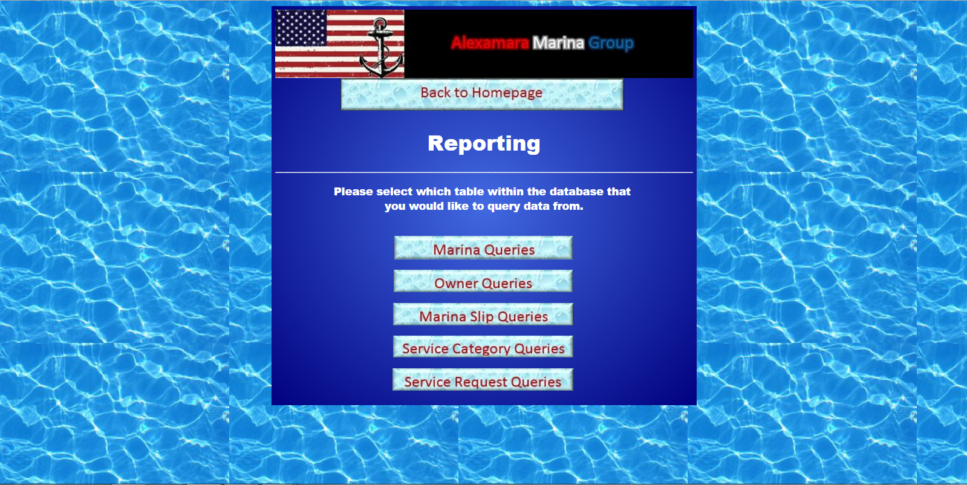

To query data within the MARINA table, click on Marina Queries and it will take you to the following page:

From this page, and any other page within the reporting portion of the site, there will be a button towards the top of the page that can take you back to the main reporting page.

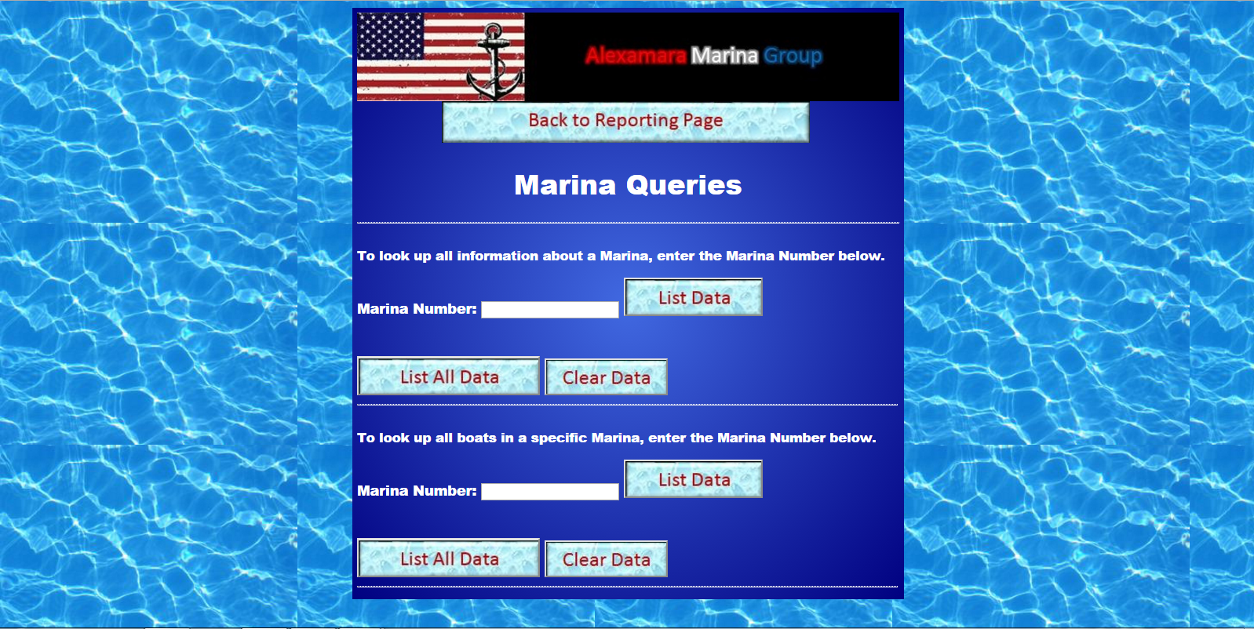

Once a valid marina number is entered in the marina number field and the user clicks list data, all the data for that specific record will be displayed on the page.

If the marina number field is left blank or the marina number entered doesn’t exist, the page will display an error message explaining that problem.

If the user clicks on List all data, all records within the MARINA table will be displayed on the page.

On the second portion of the page, the user can look up boats in a specific marina by entering the marina number and clicking list data.

If the user would like to view all the data for every boat in both marinas, they can clikc the list all data button right under that second marina number field.